 | WEST GEORGIA SHRM  Board Meeting  February 2013  Cobb Board Room,  LaGrange College | 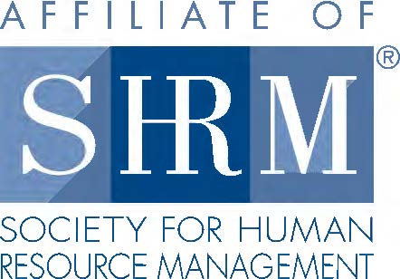

I. Call to Order/Welcome
A) Minutes
B) Treasurers Report
C) Chair Reports

II. Old Business
A) Review 2013 Board

C) Speakers
January Page Estes - Chamber
February Penelope Harbour – Employer Support of the Guard
March LEADERSHIP CONFERENCE
April Domestic Violence and the Workplace ???
May Occupational Medicine ???
June EEOC???
July NONE - VACATION
August
September
October
November
December Randy Nix (Not Confirmed)

III. New Business
Leadership Conference: March 14, 2013

1. Location: Del’avant
(a) Room Setup (same as last year) – Tami
(b) Reserved Table for Speakers – Michael/Tami
(c) Registration
(d) Silent Auction
(e) Posters
2. Speakers – Tami
(a) Bill Principe – OSHA
(b) Tommy Eden – Constangy Brooks
(c) Jonathan Martin – Constangy Brooks
3. Brochure and Advertisements
4. Food
6. HRCI Credit - Diana
7. Sponsorships

